Assignment 1:

1. Create a VM in the west US region

2. Select the Ubuntu image for creating the VM

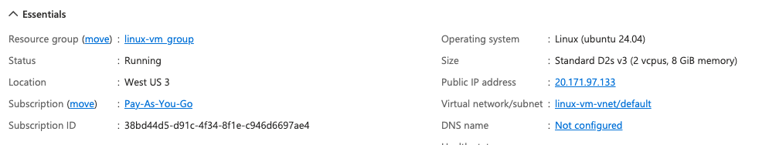

3. Open the SSH port

4. Connect to the Linux VM using the terminal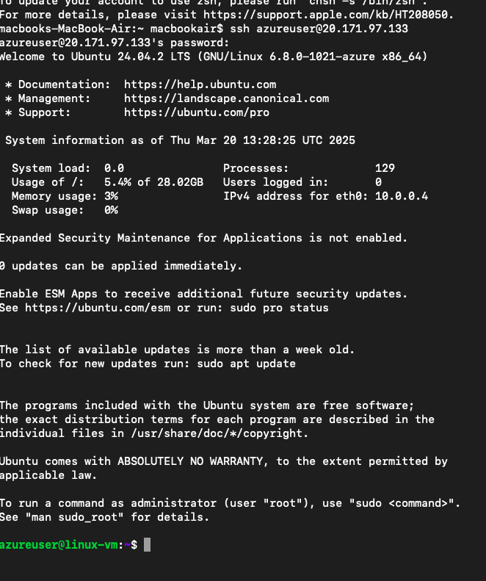

Assignment 2:

1. Create a Windows VM in west US region 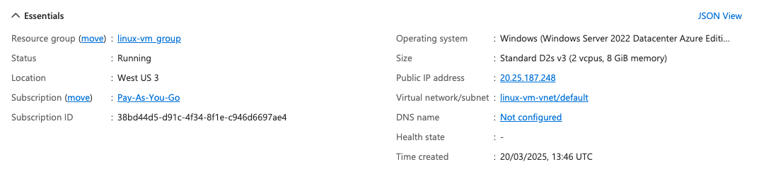

2. Open the RDP port

3. Connect to it using Windows Remote Desktop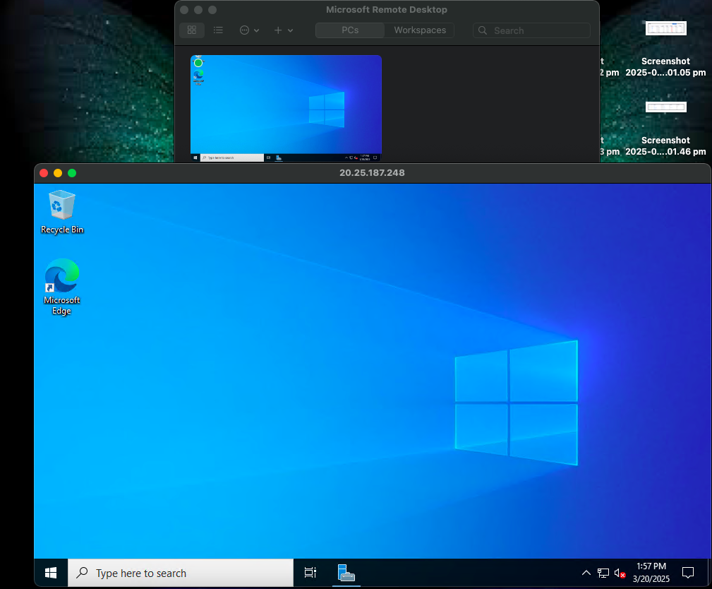

Assignment 3:

1. Create a VM scale set with Ubuntu as OS

2. Give min VM’s as 1 and maximum as 5

3. For scale-out CPU % is 75 and increase by 1 VM

4. For scale-in CPU % is 25 increase by 1 VM

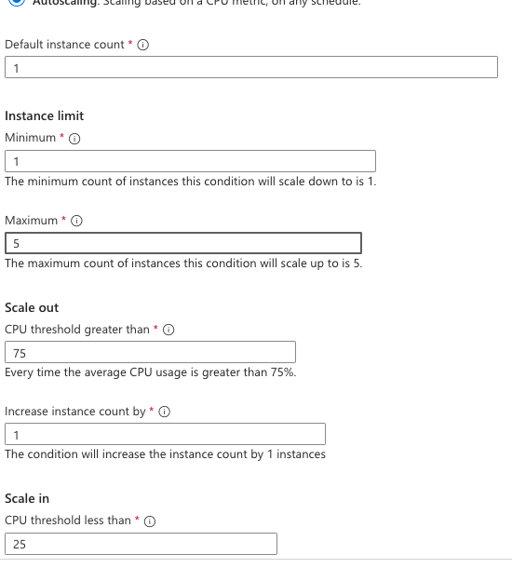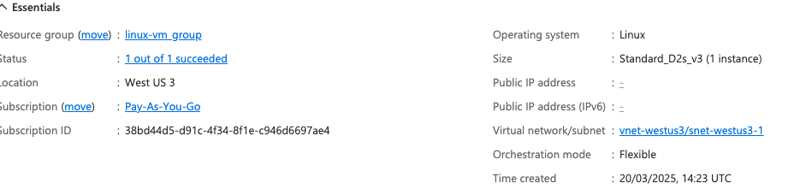

Assignment 4:

1. Create a Linux VM with Ubuntu OS

2. Install Apache2 software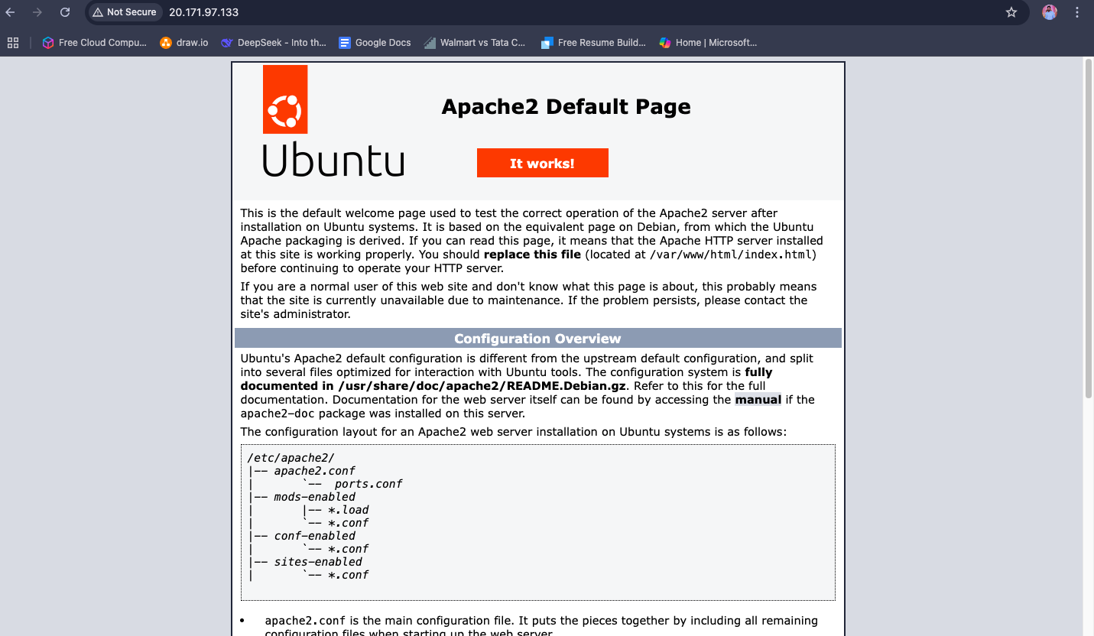

3. Create image out of VM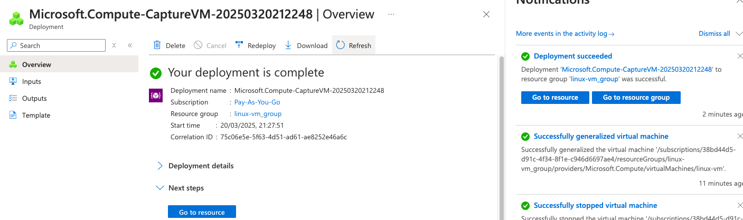

Assignment 5:

1. Deploy a VM from the previously created image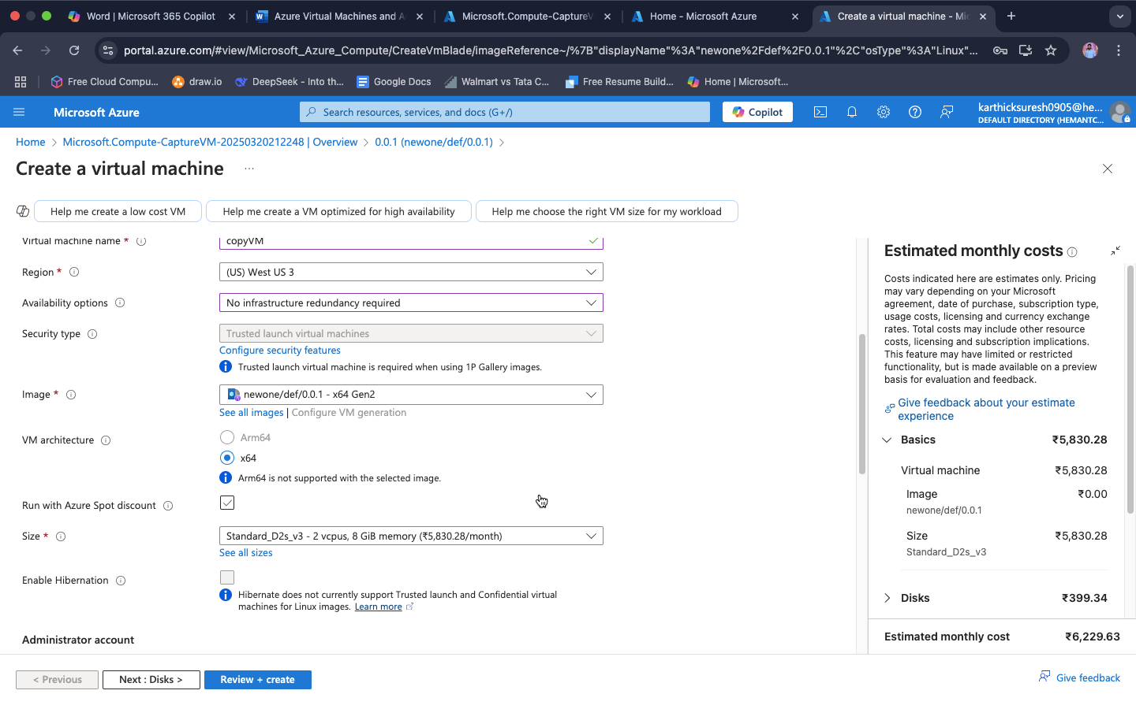

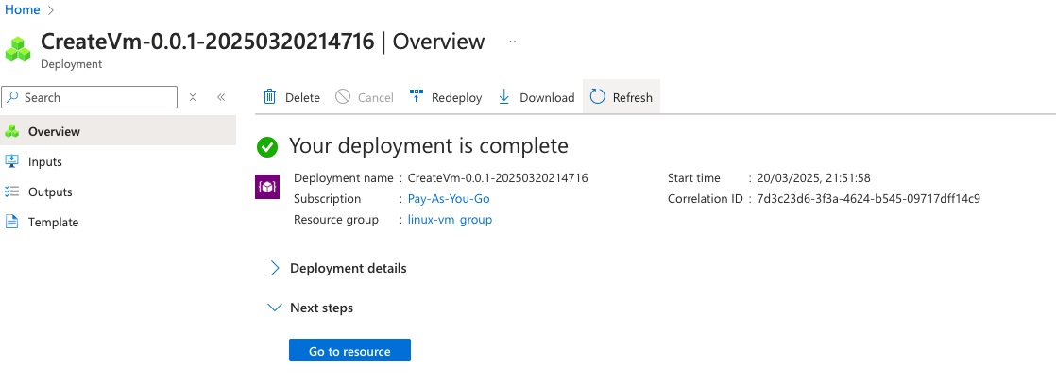

2. Open port 80 in NSG 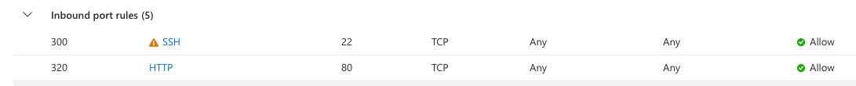

3. Start the Apache2 service in the VM

4. Verify if you are able to access the website